**WPF + Entity Framework: выбор, вывод, обновление и удаление данных** Шаг 1.

Создадим таблицу User с помощью MSSQL. Таблица должна содержать следующие поля: Id, Login,Password,FirstName, LastName, MidlleName.

Соединение с сервером:

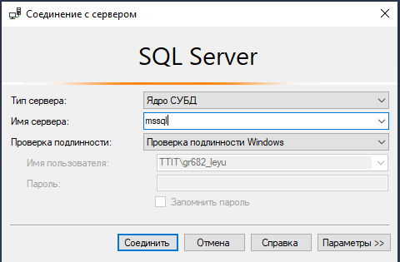

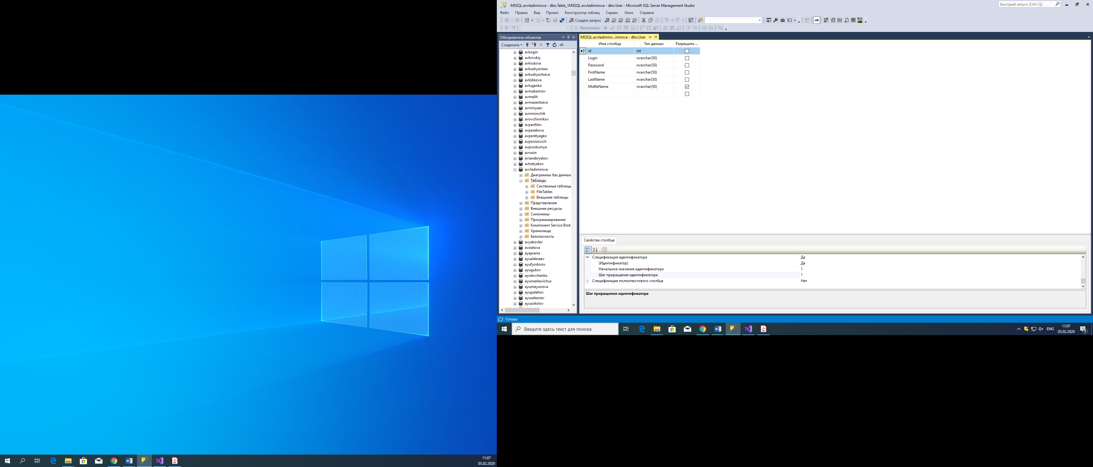

Добавляем первичный ключ и ставим автоинремент.

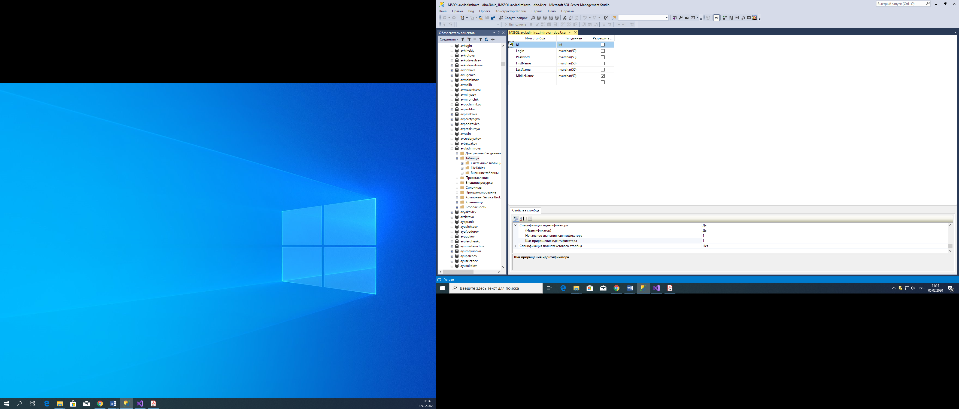

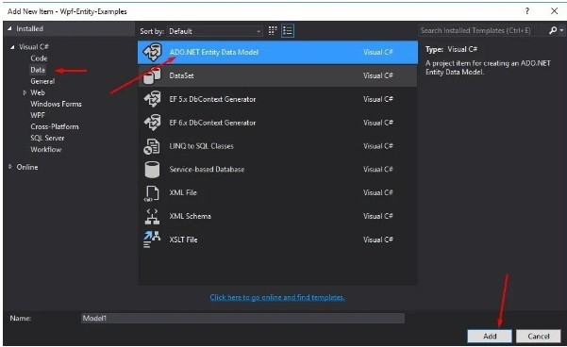Шаг 2.

Подключение БД к проекту WPF.

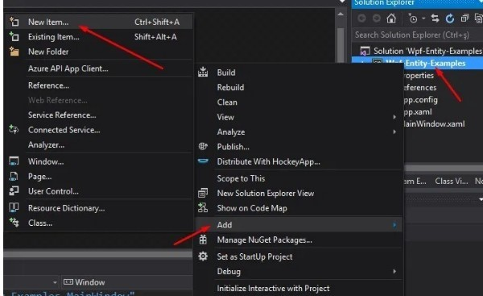

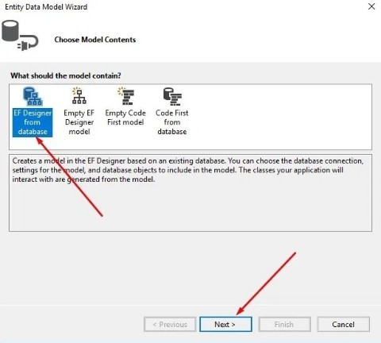

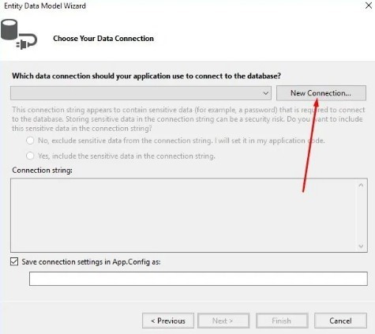

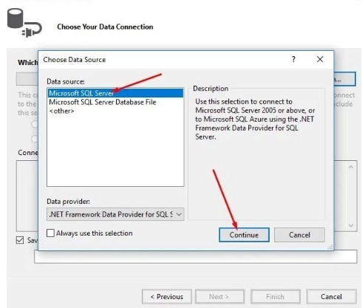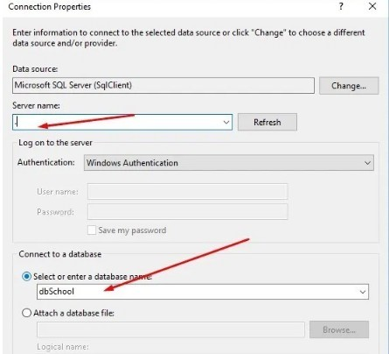

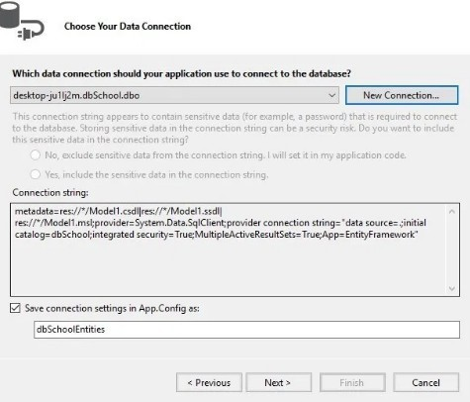

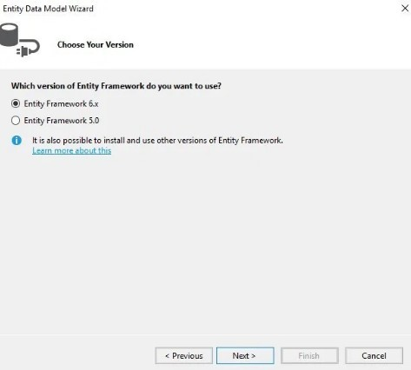

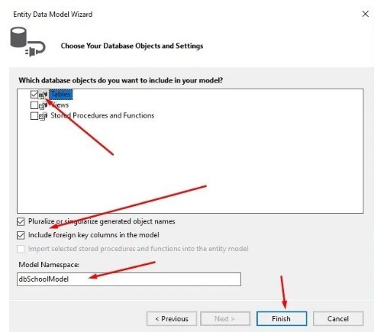

Ждём добавления модели. Модель будет доступна в «Обозревателе решений».

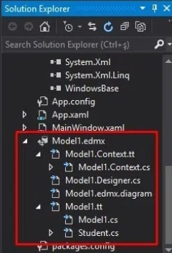

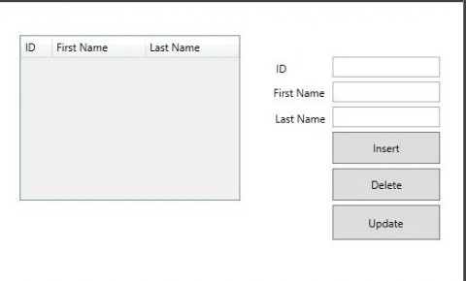Добавляем элементы на окно WPF через разметку XAML: <Window x:Class="Wpf_Entity_Examples.MainWindow"

|  |
| --- |
| xmlns="http://schemas.microsoft.com/winfx/2006/xaml/presentation" |
| xmlns:x="http://schemas.microsoft.com/winfx/2006/xaml" |
| xmlns:d="http://schemas.microsoft.com/expression/blend/2008" |
| xmlns:mc="http://schemas.openxmlformats.org/markup-compatibility/2006" |
| xmlns:local="clr-namespace:Wpf_Entity_Examples" |
| mc:Ignorable="d" |
| Title="www.csharp-console-examples.com" Height="350" Width="525" Loaded="Window_Loaded"> |
| <Grid> |
| <DataGrid Name="dgogrenci" HorizontalAlignment="Left" AutoGenerateColumns="False"  Height="185" Margin="22,37,0,0" VerticalAlignment="Top" Width="246"> |
| <DataGrid.Columns> |
| <DataGridTextColumn Binding="{Binding ID}" Header="ID" Width="*"/> |
| <DataGridTextColumn Binding="{Binding FirstName}" Header="First Name" Width="3*"/> |
| <DataGridTextColumn Binding="{Binding LastName}" Header="Last Name" Width="3*" /> |
| </DataGrid.Columns> |
| </DataGrid> |
| <TextBox Name="txtId" HorizontalAlignment="Left" Height="23" Margin="371,61,0,0"  TextWrapping="Wrap" Text="" VerticalAlignment="Top" Width="120"/> |
| <TextBox Name="txtFirst" HorizontalAlignment="Left" Height="23" TextWrapping="Wrap" Text=""  VerticalAlignment="Top" Width="120" Margin="371,89,0,0"/> |
| <TextBox Name="txtLast" HorizontalAlignment="Left" Height="23" TextWrapping="Wrap" Text=""  VerticalAlignment="Top" Width="120" Margin="371,117,0,0"/> |
| <Button Content="Insert" HorizontalAlignment="Left" Margin="371,145,0,0" VerticalAlignment="Top" Width="120" Height="36" Click="Button_Click"/> |
| <Button Content="Delete" HorizontalAlignment="Left" Height="36" Margin="371,186,0,0"  VerticalAlignment="Top" Width="120" Click="Button_Click_1"/> |
| <Button Content="Update" HorizontalAlignment="Left" Height="39" Margin="371,227,0,0"  VerticalAlignment="Top" Width="120" Click="Button_Click_2"/> |
| <Label x:Name="label" Content="ID" HorizontalAlignment="Left" Margin="303,61,0,0" VerticalAlignment="Top"/> |
| <Label x:Name="label1" Content="First Name" HorizontalAlignment="Left" Margin="300,88,0,0" VerticalAlignment="Top"/> |
| <Label x:Name="label2" Content="Last Name" HorizontalAlignment="Left" Margin="302,117,0,0" VerticalAlignment="Top"/> |
| </Grid> |
| </Window> |

В результате наше окно приобретает следующий вид:

Переходим к написанию кода для нашего окна: using System;

|  |
| --- |
| using System.Collections.Generic; |
| using System.Linq; |
| using System.Text; |
| using System.Threading.Tasks; |
| using System.Windows; |
| using System.Windows.Controls; |
| using System.Windows.Data; |
| using System.Windows.Documents; |
| using System.Windows.Input; |
| using System.Windows.Media; |
| using System.Windows.Media.Imaging; |
| using System.Windows.Navigation; |
| using System.Windows.Shapes; |
|  |
| namespace Wpf_Entity_Examples |
| { |
|  |
| public partial class MainWindow : Window |
| { |
| dbSchoolEntities db; |
| public MainWindow() |
| { |
| InitializeComponent(); |
| } |
|  |
| private void Button_Click(object sender, RoutedEventArgs e) |
| { |
| Student student = new Student(); |
| student.FirstName = txtFirst.Text; |
| student.LastName = txtLast.Text; |
| db.Students.Add(student); |
| db.SaveChanges(); |
| dgogrenci.ItemsSource = db.Students.ToList(); |
| } |
|  |
| private void Button_Click_1(object sender, RoutedEventArgs e) |
| { |
| int num = Convert.ToInt32(txtId.Text); |
| var dRow = db.Students.Where(w => w.ID == num).FirstOrDefault(); |
| db.Students.Remove(dRow); |
| db.SaveChanges(); |
| dgogrenci.ItemsSource = db.Students.ToList(); |
| } |
|  |
| private void Button_Click_2(object sender, RoutedEventArgs e) |
| { |
| int num = Convert.ToInt32(txtId.Text); |
| var uRow = db.Students.Where(w => w.ID == num).FirstOrDefault(); |
| uRow.FirstName = txtFirst.Text; |
| uRow.LastName = txtLast.Text; |
| db.SaveChanges(); |
| dgogrenci.ItemsSource = db.Students.ToList(); |
| } |
|  |
| private void Window_Loaded(object sender, RoutedEventArgs e) |
| { |
| db = new dbSchoolEntities(); |
| dgogrenci.ItemsSource = db.Students.ToList(); |
| } |
| } |
| } |
|  |

В результате получаем рабочее приложение:

